Investigate how network conditions/impairments affect end-to-end video streaming quality.

Alistair Drew

10567887

## Abstract (150)

* Adaptive video streaming over SDN and NFV
* Effects of packet loss and delay are different form UDP and are displayed as buffering events
* Explain briefly the investigation and the measures of how it is getting carried out
* Explain Network QoS, Application QoS and User QoE.

Extremely popular HTTP adaptive video streaming (HAS) services over the internet such as Over the Top solutions (OTT) like YouTube, Netflix and Twitch must maintain the Quality of Experience of their end-to-end video streaming to remain popular. Due to this Video Service Providers (VSP’s) need to investigate how network conditions, the basest level of the operation effect the Quality of Experience for the user. This report is an investigation into the effect network conditions have on the end-to-end video streaming quality. Software Defined Networks (SDN) allow for which are designed to increase the flexibility of the network by making it easy to manage and adapt how traffic is handled. and Network Function Virtualization (NFV) that allows abstraction of network functions from dedicated hardware to standard hardware allowing for flexible network topology creation

are used to run a battery of experiments on a test bed.

## Introduction and background (700)

* Background information and literature on SDN, DASH
* Video streaming quality
  + Objective and Subjective measures of video quality
  + How its measured in this context
* Tasks to be carried out
  + Steps the investigation needs to carry out
    - Research into the background of the investigation topic
    - Explanation of the necessary technologies and their roles in the investigation
    - Creation of the testbed
    - Designing the experiments with research and analysing the results
    - Critically evaluation the process of the investigation.
* Structure of the report
  + Intro to the components of the investigation and the investigation itself
  + The testbed and its development
  + How the experiments where designed, the results and how they tie into the investigation. Analyse the patterns and trends.
  + Critical evaluation on the investigation and explaining and justifying the network management via REST API
  + A summarization of the investigation findings in the conclusion.

### SDN

Proprietary hardware was king in the networking world until the arrival of software-defined networking (SDN), an approach which can both simplify and allow granular control of networks adaptively to adjust for network conditions. This facilitates network configuration and management (Bonfim, Dias and Fernandes, 2019). This makes it especially well-suited for testing the effects network (QoS) parameters have on application (QoS) parameters and in turn the users Quality of Experience (QoE) as shown in Figure 1. (radar chart ref)

SDN is done through ‘programming’ the network via a centralised controller located in the control plane, the SDN controller makes the decisions on how network traffic is controlled. The data plane which contains the network nodes like switches and hosts are responsible for forwarding traffic according to a set of rules created by the SDN controller. The SDN controller has direct control of the data plain through the southbound protocol OpenFlow.

The purpose of using SDN is to allow easier network management and greater flexibility of traffic flows while also abstracting the implementation of the control plane to non-proprietary software such as open API’s like RYU.

Explain how the SDN controller and OpenFlow switch communicate using flow tables and headers ecs. Then tie it into the investigation 🡪 How changing network QoS effects application QoS and in turn user QoE 🡪 How that benefits the investigation.

### Dash

### Video Streaming Quality

HAS quality is defined as … it can be measured in two ways. Objectively using MOS metrics and Subjectively using

### Steps Taken

The investigation can be divided into a series of steps to be taken sequentially, the first of these steps is to research into the background of HAS and how network conditions effect the QoE of end-to-end video streaming. The second step is to use the research to choose suitable technologies to build the test bed. The third step is to create the test bed itself. The fourth step is to design experiments that measure the correct metrics (packet loss, delay, bw, initial delay, average buffering length, buffering frequency). The fifth step is to carry out the experiments, then analyse and critically evaluate the results. The sixth step is to summarize the key points and conclude

### Report Structure

The structure of the report is split into five parts, section one is the introduction to content of the report and the background information as well as pertinent literature. Section two details and justifies the design of the test bed and its development. Section three explains and justifies the experiments carried out on the test bed as well as analyses the results from the experiments. Section four is about critical evaluation of the report so far as well as the network management via REST API. Finally, section five is the conclusion that is an executive summery of the report.

## Testbed and development (600)

* Setup of testbed
  + Explain the automated script file setup
* Configuration of the testbed
  + Justify the structure of the testbed and why it was designed the way it was, and any problems in its development
* Code developed
  + Python, JavaScript or shell scripts created

## Experiments, Results and Analysis (600)

## Discussions, network management via REST API (700)

## Conclusions (150)

## References

<https://ieeexplore.ieee.org/stamp/stamp.jsp?arnumber=8930519&tag=1>

Barakabitze, A., Barman, N., Ahmad, A., Zadtootaghaj, S., Sun, L., Martini, M. and Atzori, L., 2020. QoE Management of Multimedia Streaming Services in Future Networks: A Tutorial and Survey. *IEEE COMMUNICATIONS SURVEYS & TUTORIALS*, 22(1).

**In-text:**(Barakabitze et al., 2020)

<file:///C:/Users/Adrew2/Downloads/Measuring_the_Quality_of_Experience_of_HTTP_Video_.pdf>

Mok, R., Chan, E. and Chang, R., 2018. Video Quality Representation Classification of Encrypted HTTP Adaptive Video Streaming. *KSII Transactions on Internet and Information Systems*, 12(8).

**In-text:**(Mok, Chan and Chang, 2018)

https://dl.acm.org/doi/pdf/10.1145/3172866

Bonfim, M., Dias, K. and Fernandes, S., 2019. Integrated NFV/SDN Architectures. *ACM Computing Surveys*, 51(6), pp.1-39.

**In-text:**(Bonfim, Dias and Fernandes, 2019)

<https://ieeexplore.ieee.org/stamp/stamp.jsp?tp=&arnumber=6994333>

SDN Intro

<https://www.researchgate.net/publication/221293512_Measuring_the_Quality_of_Experience_of_HTTP_Video_Streaming>

Radar chart

<https://www.mdpi.com/2076-3417/10/21/7691/htm>

Dash

## Appendix

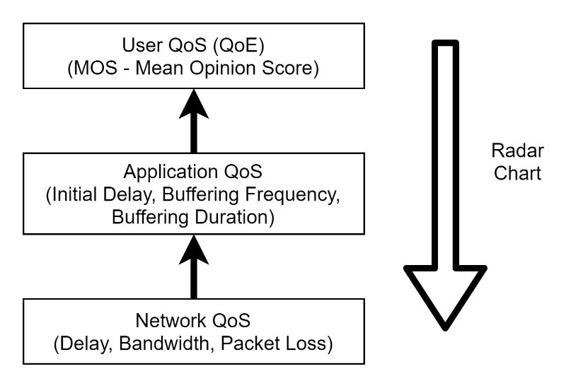

Figure 1 Three levels of QoS considered in this paper.

https://unilearning.uow.edu.au/report/4bi1.html